Digital Design VHDL Project Report

Introduction
The aim of this project was to create a peak detector that when fed a series of hexadecimal data values the peak value was identified along with the proceeding and previous three values. This detector is run on a Xilinx Spartan-6 FPGA development board and communications between the board and desktop computer is handled via the UART RS-232 protocol. Along with the main feature of peak detection, the system had to respond to certain input commands and produce results as requested.

Group
As group 17, our four person group consisted of Daryl White, Alexander Hamilton, Sylvia Betrosian and Adreas Michaelides. We met initially to discuss the project and split up into pairs to work on the Data Processor and Command Processor. Daryl White and Alexander Hamilton designed and built the Data Processor and Sylvia Betrosian and Adreas Michaelides designed and built the Command Processor.

Plan
A large part of this assignment was learning to break down large portions of a project into smaller tasks that could be allocated to each group member and the experience of coordinating work efforts so that each component integrated correctly once the final system was built.
Our group decided to meet every two weeks to discuss progress and problems and, before the interim deadline, test the interaction of the data processor and command processor.
Within each two person team a Gantt chart was drawn up to plan when each segment of the respective processor should be completed by.

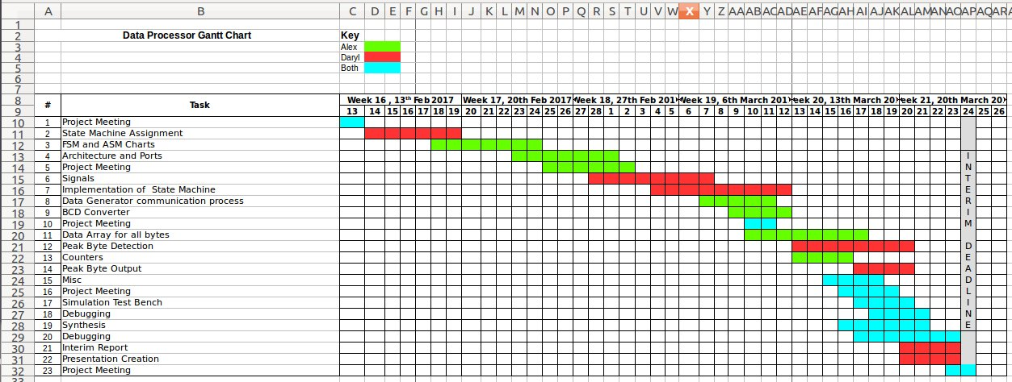
The key milestones for this project were the interim assignment deadline (working code and report) on Friday 24th March and the full system synthesised deadline on 28th April and the presentation date of Tuesday 28th March.

Data Processor
Our Data Processor first waits for the start signal from the command processor to start the retrieval of data from the data processor. The number of data bytes to be retrieved is specified by the command processor as well in the form of the signal numWords_BCD. The data processor converts the BCD numbers into a single integer.
The data processor retrieves data from the data generator by changing the value of ctrlOut which is interpreted by the data generator as a request for bytes. ctrlOut will keep switching until the number of switches is equal to the number of bytes requested.
As the data bytes come in, they are allocated a position a global array. While being allocated, each data byte is compared to the current peak value. The peak is initialised as having the value of “10000001” which is the smallest negative number and if the byte coming in is greater than the current peak, it becomes the highest peak and its position is saved. The individual data bytes are also sent to the command processor after they are saved in the global array.
After all the data bytes are sent out, the peak byte and the 3 bytes preceding and following the peak are allocated into dataResults while the peak index is converted into the BCD format for maxIndex. Once the peak value has been converted, seqDone is asserted.
Below are the finite state machine and algorithmic state machine diagrams.
By creating these diagrams, we could plan and visualise what we designed, saving time on improvising code that would not lead anywhere and be slower. These are not our original versions of our state machine as we have had to make several changes from our starting idea when we realised that they weren’t synthesisable or if there were better ways of doing things.

To explain the data processor we have broken this section into architecture, signals and processes and gone into detail about our choices within each section.

Architecture
We decided to use a single architecture called ‘dataConsume’, we initially considered multiple architectures for modularity but felt that this would increase complexity and possible duplication of signals.

States
The follow states where used in our state machine
- init – This is the initial state that waits for the ‘start’ signal to arrive from the command processor before moving on to ‘dataRequest’
- dataRequest – Second state that is conditional upon a signal ‘dataArrived’ which signifies when data is being received from the data generator.
- dataRequestSwitch – Third state that switches the toggle along with sendBytesSwitch.
- sendBytes – Forth state checks for the end condition of all data being received from the data generator before moving onto the peak byte assignment.
- sendBytesSwitch – Fifth state that also toggles similar to dataRequestSwitch.
- assignPeak – Sixth state that assigns the peak byte, three preceding bytes and three post bytes.
- sendPeak – Seventh state, this is the final state that sends the results to the command processor and returns to the initial state.

Signals
- curState, nextState: state_type; - Used for moving through the state machine
- numWordsReg: BCD_ARRAY_TYPE(2 downto 0); -Stores ‘numWords’ in a register.
- integerPosistion3,integerPosistion2,integerPosistion1, totalSum : integer; - Integers involved in summing ‘numWords’.
- N: integer := 0; - Controls the allocation of the data into the array.
- resetCounter: std_logic; - A synchronous reset signal that resets counters and the peak byte.
- beginRequest, endRequest: std_logic; - Tell the processor to stop and start requesting data from the generator.
- totalDataArray : CHAR_ARRAY_TYPE(0 to 999); Stores every byte received.
- rollingPeakBin : signed(7 downto 0) := "10000001"; - Stores the current peak byte in binary.
- peakIndex: integer; – The index of the peak byte.
- ctrl_2Delayed, ctrl_2Detection: std_logic; - Ctrl_2 detection signals.
- resultsValid: std_logic; - This signal goes high once all the received bytes have been compared.
- dataArrived: std_logic; - Check that data has started to be allocated into the global array.
- conversionComplete: std_logic; - Check that ‘peakIndex’ has been converted into a BCD format.
- toggle: std_logic; - Used for toggling ctrlOut between 1 and 0
- switch: std_logic; -- Used to switch between states that alters toggle
- signal countEn: std_logic; -Enables the counter for number of switches.
- signal countInt: integer; - Counts the number of switchesounters and the peak byte
- signal count100, count10, count1: unsigned(3 downto 0); - For converting integer into BCD format.
- signal flag100,flag10,flag1: std_logic; - Checks for the conversion of integers into BCD format.

Processes

Processes handling the state machine
- state_reg: process(clk, reset) - This process returns the state machine to the initial state upon the reset signal going high and changes the current state to the next state on the clock edge.
- state_order: process(clk,curState) – The main state machine process, this is responsible for executing conditionals in each state.
- combinational_output:process(curState) – As we are using Moore architecture this process provides the outputs for the states.

Processes handling numWords_BCD
- register_numWords:process(start, clk) -- This is just a simple register to store the value numWords_bcd on the rising clock edge. This is an easy way to avoid latches.
- convert_numWords:process(numWordsReg, reset) - This is the process for converting each digit in numWords_bcd into a way that is readable for our machine. This is done by converting each of the bit vectors into unsigned bit arrays followed by integers.
- summing_numWords:process(integerPosistion1, integerPosistion2, integerPosistion3) – Each of the integers are then multiplied by their corresponding position (integerposition3 represents the hundreds and is therefore multiplied by 100) and summed together to produce the integer format of numWords_bcd which is saved as a signal in the form of ‘totalSum’. The last two signals could have been compressed together to form a single process to reduce the number of lines.

Processes handling the handshaking protocol
- ctrl_out_switching:process(toggle) - When going into the "switch" states, ctrlOut changes to 1. The changing between a state and its ‘switch’ state causes toggle to be asserted which in turn changes ctrlOut.
- ctrlOut_counter : process(CLK, countEN, reset, resetCounter, totalSum) - Counts the number of times a transition has occurred on the ctrlOut line. The counter stops counting when the number of transitions made is equal to the total sum.
- request_data:process(countInt, totalSum, beginRequest) - Signals to the state machine when to transition to the switch states.

Storing data processes
- delay_ctrl_2:process(clk) – This process saves the value of what is currently ctrlIn into a register. This registered value is then compared below in the global_data_array process.
- send_byte:process(clk, dataArrived, reset, totalDataArray, N, totalSum) – Passes each byte received from the Data Generator directly to the Command Processor as required in the specification.
- global_array_counter: process(CLK, reset, resetCounter) - Controls the index of the global data array.
- global_data_array: process(beginRequest, N, ctrl_2Detection, totalSum) - This process is responsible for saving the data coming into the data processor from the data generator. It first XOR’s the values of ctrl_2Delayed and ctrlIn to check if they are different. If they are different, this allows this process to detect a change in the value of ctrlIn which represents that the data from the generator is ready. The process then saves this data value into the Nth position in the global data array. N is then increased by 1 and the signal representing that the first byte of data has been saved, is asserted. The array will stop saving values into the array then the value of N is greater than the totalSum – 1 in which a signal will be asserted to represent the end of the assignment of data bytes.
- global_data_allocation:process(clk, reset, ctrl_2Detection, data, N) - Allocates the bytes from the data generator in the data array on the rising clock edge.

Detector Process
- Detector: process(clk, reset, resetCounter, beginRequest) – This process is compares each incoming byte against the current peak byte, if it is larger then the ‘rollingPeakBin’ and ‘peakIndex’ signals get updated.
- maxIndex_counters:process(CLK, reset, resetCounter, resultsValid, flag100,flag10,flag1) - Counters involved in converting an integer into bcd format.
- peakIndex_to_BCD:process(peakIndex, resultsValid, count100, count10, count1, flag100, flag10) – This process converts the ‘peakIndex’ into the BCD format using triple counters for the ones, tens and hundreds. Each digit is found in order from right to left (hundreds, followed by tens and ones). Flags are used to signal to count the next digit in the peak index
- maxIndex_allocation:process(clk, reset, flag1) - When the ones have been found, the maxIndex is set on a rising clock edge
- requested_results: process(reset, resultsValid, totalDataArray, peakIndex,clk) - Allocates the peak byte and the 3 bytes preceding and following the peak byte. We currently don’t have a way of dealing with corner cases (if the peak byte is close to the beginning or end of the sequence.
Code management
We used git for our version control system and our code is available on GitHub at https://github.com/darylw357/digital_design_group

We felt it was important do this as we could track each change made by our respective partner and reduced the chance of duplicated efforts or code breaking. It also allowed us to get the core functionality then improve upon that with experimental branches without risking our working project.

Synthesis and other issues

The first big issue we had was with the counters for the number of switches. When we initialised the ctrlOut signal, we didn’t realise that it would affect the counter and such there would be the correct number of bytes from the data generator requested in the first sequence but the following sequences would have 1 too many bytes requested. This was later fixed by separating the initialisation and the counter.
Synthesis was an issue as well since a lot of our processes combined sequential and combinatorial logic. In the final week, most of our time was spent rewriting our processes so that they would work in Xilinx. This also meant we have quite a few latches in our code. By adding more register and separating the allocation of data into their own processes removed most of these latches.
The last problem which we have and haven’t been able to fix is the issue with the resets which makes our code non-compatible with the spartan6 board with asynchronous resets and asynchronous sets. We have tried fixing this by checking that resets were not left in any of the combinational process when we separated them to make them synthesisable.

Command Processor

Group to add their report here.

Conclusion

This digital design project provided challenges in designing a complex system within the VHD language and working within unfamiliar groups to achieve a common goal. However we , as a group, felt that overall this project was successful in implementing the required specification of a hexadecimal data peak detector on Xilinx Spartan-6 hardware.

